Object in JS is hash table. In Python they called dictionaries

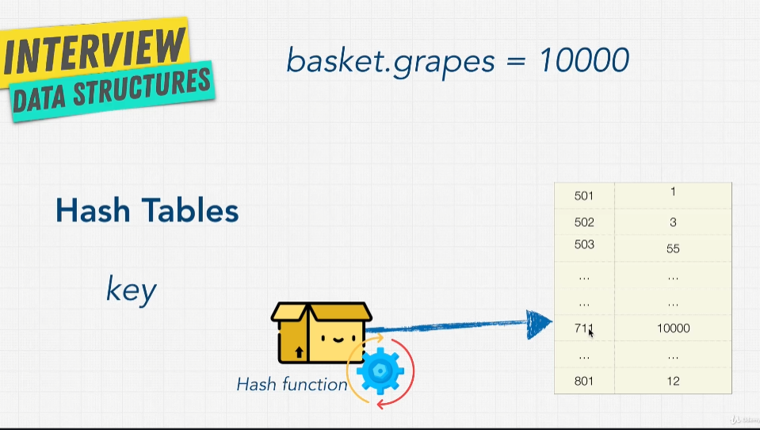

Technically it stores both properties and keys actually.

Hash function is just a function that generate a value of fixed length for each input that it gets. Key aspects of hash function:

1. One way, no idea to convert back
2. Same input gives same output

This is idempotent – always produce same output with same input

Hash tables exist in all language, they use optimum hash function

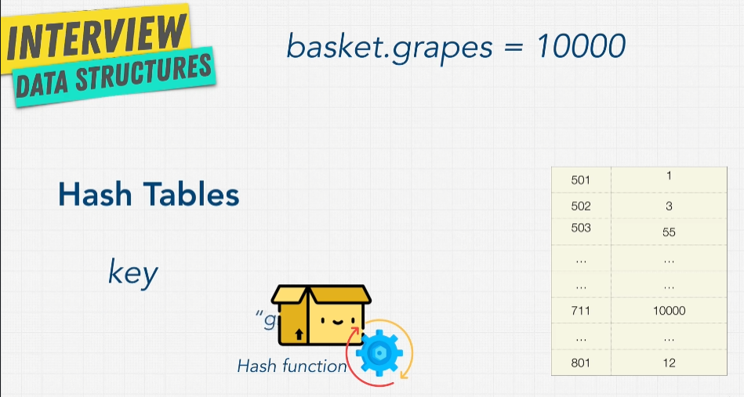

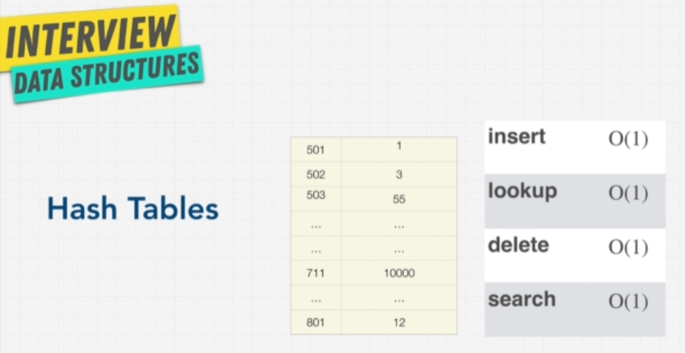

Hash Table Pros and Cons

<https://www.cs.usfca.edu/~galles/visualization/OpenHash.html>

Hash Collision

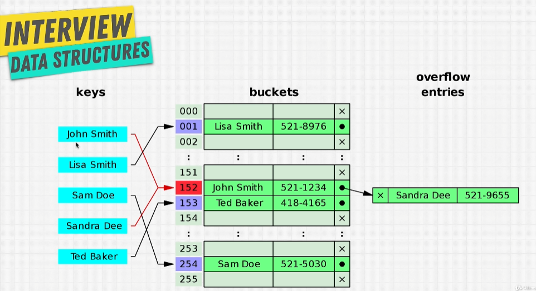

Two keys into same address! We always going to have collision, we need method to able to store those 2 keys values

Why Hash Tables

Its good to accessing certain value

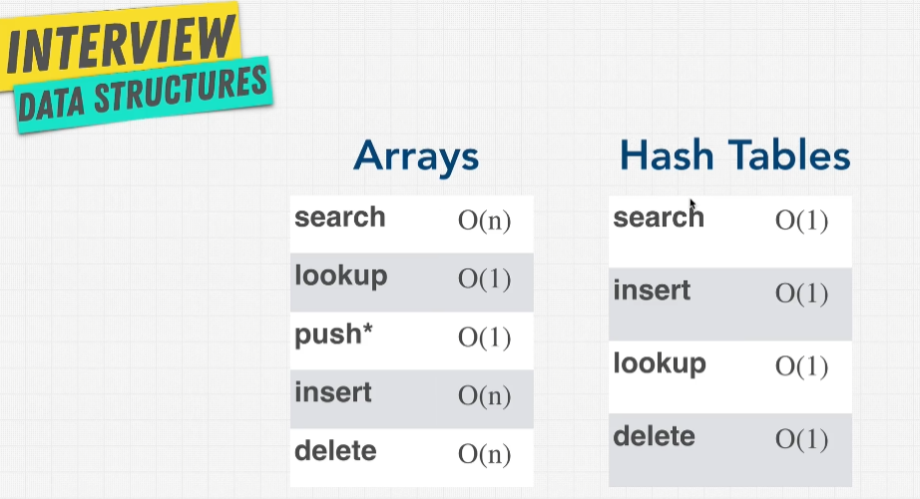

In hash table has no concept or order, unlike array arranged with indexes

